A Project Report

on

**PLACEMENT MANAGEMENT SYSTEM**

**Technical Skilling - III**

A project report submitted in partial fulfillment of the requirements for the degree of Bachelor of Technology in Computer Science and Engineering

by

Pydikondala Lahari (2010030372)

Kolli Mounika (2010030384)

Kamani Nandini (2010030385)

Pulugam Keerthana (2010030445)

Under the guidance of

**SASIDHAR**

Assistant professor



**Koneru Lakshmaiah Deemed to be University**

**DEPARTMENT OF COMPUTER SCIENCE AND ENGINEERING**

(Aziznagar, Hyderabad)

**CERTIFICATE**

This is to certify that the Project work entitled “**Placement management system**” is carried out by **Pydikondala Lahari (2010030372) , Kolli Mounika (2010030384), Kamani Nandini (2010030385), Pulugam Keerthana (2010030445)** partial fulfillment for the award of degree of **Bachelor of Technology** in **Computer Science and Engineering**, KL University, Aziznagar, Hyderabad during the academic year 2022-2023.

SASIDHAR

Internal Guide

Signature of the HOD External Examiner

(Certificate from Industry)

## DECLARATION

I hereby declare that the project titled “Placement and Intelligent System” submitted to Computer Science and Engineering, Koneru Lakshmaiah University, Aziznagar, Hyderabad for the award of the degree of Bachelor of Technology in Computer Science and Engineering is a result of original work carried-out in this project report. I understand that my report may be made electronically available to the public. It is further declared that the project report or any part thereof has not been previously submitted to any University or Institute for the award of degree or diploma.

Name of Student(s) : Pydikondala Lahari, Kolli Mounika, Kamani Nandini, Pulugam Keerthana

Hall Ticket Number(s): 2010030372, 2010030384, 2010030385, 2010030445

Degree : Bachelor of Technology in Computer Science and Engineering

Department : Computer Science and Engineering [CSE]

Title of the project : Placement and information system

Pydikondala Lahari

Kolli Mounika

Kamani Nandini

Pulugam Keerthana

**Date:** 28-11-2022

**ACKNOWLEDGEMENT**

First and foremost, we thank the lord almighty for all his grace & mercy showered upon us, for completing this project successfully.

We take grateful opportunity to thank our beloved Founder and Chairman who has given constant encouragement during our course and motivated us to do this project. We are grateful to our Principal **Dr. L. Koteswara Rao** who has been constantly bearing the torch for all the curricular activities undertaken by us.

We pay our grateful acknowledgement & sincere thanks to our Head of the Department **Dr. Chiranjeevi Manike** for his exemplary guidance, monitoring and constant encouragement throughout the course of the project.

We thank **Project Supervisor(s) Sasidhar** of our department who has supported throughout this project holding a position of supervisor.

We whole heartedly thank all the teaching and non-teaching staff of our department without whom we won’t have made this project a reality. We would like to extend our sincere thanks especially to our parents, our family members and friends who have supported us to make this project a grand success.

Pydikondala Lahari (2010030372)

Kolli Mounika (2010030384)

Kamani Nandini (2010030385)

Pulugam Keerthana (2010030445)

## ABSTRACT

The project named "Placement Management System", is a student/company information system. The project has been developed on the basis of "Placement Cell" being presently used in the University for storing and retrieving the information of students and companies who are registered in placement cell. The Placement Cell maintains a large database of students wherein all the information of student is stored. It is a web based application created in Java which will help students as well as the administration authority to carry out each and every activity in campus hiring.

This system is an application that can be accessed throughout the university with proper login credentials. This project reduces manual work and maximum the optimization, abstraction and security.

**Keywords:**

Authentication, Authorization, Management system, Automation, Eligibility, Database, Data records, Student, Admin, HOD.

## TABLE OF CONTENTS

|  |  |  |
| --- | --- | --- |
|  | | **Page** |
| **CHAPTER 1: INTRODUCTION** | | 9 |
| 1.1 | Introduction | 9 |
| 1.2 | Problem statement | 9 |
| 1.3 | Scope of research | 10 |
| 1.4 | Research hypothesis | 10 |
| 1.5 | Objectives | 11 |
| 1.6 | Organization of the report | 11 |
| **CHAPTER 2: LITERATURE REVIEW** | | 12 |
| 2.1 | Summary of literature review and research gap | 12 |
| **CHAPTER 3: METHODOLOGY** | | 14 |
| 3.1 | Flow chart | 14 |
| 3.2 | Summary of methodology | 14 |
| **CHAPTER 4: RESULTS AND DISCUSSION** | | 15 |
| 4.13 | Summary of results and discussion | 15 |
| **CHAPTER 5: CONCLUSION AND RECOMMENDATIONS** | | 24 |
| 5.1 | Conclusion | 24 |
| **REFERENCES** | | 25 |
| **CHAPTER 1: INTRODUCTION**  **1.1 Introduction**  Our Placement management system is mainly focused on providing all the available latest job offers to the students. It is a platform where students can view and assess their opportunities.  The system will be having different types of accounts for different types of users such as Admin, Student, HODs, and tutor. A profile for each student is created with the necessary credentials for the portal. The system uses MySQL for database management and will sort the data of the student.  **1.2 Problem Statement**  In today's date campus recruitment is common in all colleges. The major problem is searching and updating of the student data. Placement officers have to manage the student’s profile and their documents and has to collect the information of various companies who comes for recruitment. They have to arrange profiles of students according to various streams and notify them each time according to company requirements. Placement officers submit the information of students and if any changes or updates are required in the profile of any student, it has to be done manually. This process is so difficult and tedious when the number of users increases. This is tedious and time consuming. Chances of missing data are also possible. Our Placement management system provides information on placement providers and the placements and also keeps up to date information of all students. It is a platform where students can view and assess their opportunities. | |  |

**1.3 Scope of research**

The project has a wide scope. There is no duplication of work as this was not the case when done manually. Thus it reduces labor and increases morale. The system intends user-friendly operations which may resolve ambiguity. The project is a total management and informative system, which provides the up- to-date information of all the students in the college. Our system also help the college to overcome the difficulty in keeping records of hundreds of students and searching for a student eligible for recruitment criteria from the whole thing. It helps in effective and timely utilization of resources. The project facilitates user friendly, reliable and fast management system. The placement officer itself can carry out operations in a smooth and effective manner. They need not concentrate on record keeping. The college can maintain computerized records thus reducing paper work, time and money.

**1.4 Research hypothesis**

In colleges the records were stored in excel sheets hence sorting the data is always a problem. The excel sheets are also less advanced. Hence sorting and searching problems arises. Updating Records is another tedious task. Due to the above problems the updating was very difficult and ambiguous. Another problem students face is that they are not made aware of the Training and Placement activity held in their institutions, hence there might have been a loss of opportunities.There is also a large communication gap between students and the placement officers as it is difficult to maintain coordination between them. The existing system is also inefficient as it could not take acknowledgment from the students attending a particular drive. The existing method used for placement management is not computerized.

**1.5 Objectives**

The main objective of the placement management system is to reduce manual work and time. It is difficult and time-consuming to collect all the details from each student. To avoid this problem we have planned to develop a web-based placement management system.

* Easy to find out the list of eligible students attending the drives.
* It manages the details of student records, placement training, different placements happening in and out of the college.
* Saves the time of placement officer and faculties.
* Reduces the manual works.
* This system makes student information more secure.

**1.6 Organization of the report**

The purpose of the introduction chapter is to provide an overview of the entire thesis, summary of the project and its future scope. It also tells about the basic architecture and implementation of the project.

• It contains the methodology of the system, tells about the existing system and our proposed system. Much the developed application has met client requirements.

• It explain about the different modules involved in the system and its basic overview.

• It shows class diagram of the proposal system gives the brief explanation of hardware, software, application requirements. It contains the various Frameworks implemented in our application.

• It concludes our project work and gives an idea about future scope of the project.

**CHAPTER 2: LITERATURE SURVEY**

**2.1 Summary of literature review and research gap**

1.Almahdi Alshareef, Ahmed Alkilany basically focuses on providing a simple interface for the easy collation and maintenance of all manner of student information. The creation and management of accurate, up-to- date information regarding student's academic careers is critical students and for the faculties and administration of Sebha University in Libya and for any other educational institution. A student information system deals with all kinds of data from enrolment to graduation, including program of study, attendance record, payment of fees and examination results to name but a few. All these data need to be made available through an Online Interface.

2.Prabhu T Kannan, Srividya K Bansal focuses on providing information to support the operation, management and decision-making functions of enterprises or organizations. In the face of huge amount of information, it is required to possess the student information management system to improve the efficiency of student management. Through this system, the standardized management, scientific statistics and fast query of student information can be realized, and thus the workload of management can be reduced. In this paper, a typical student information management system will be established to realize the systematization, standardization and automation of student information relationship.

3.S.R. Bharamagoudar, Geeta R.B, S.G.Totad focuses on simple interface for maintenance of student information. The creation and management of accurate, up-todate information regarding a student’s academic career is critically important in the university as well as colleges. Student information system deals with all kind of student details, academic related reports, college details, course details, curriculum, batch details, placement details and other resource related details too. It tracks all the details of a student which can be used for all reporting purpose, tracking of attendance, progress in the course, completed semesters, years. Different reports and Queries can be generated based on vast options related to students, batch, course, faculty, exams, semesters, certification and even for the entire college .

4.Shiqiu Huang, Rzhang, zhengwei Qi investigated on the Dynamic taint analysis is a prevalent approach to protect a program from malicious behaviors, but fails to provide any information about the code which is not executed. This paper describes a novel approach to overcome the limitation of traditional dynamic taint analysis by integrating static analysis Into the system and presents framework SDCF to detects of ware vulnerabilities with high code coverage. Our experiments show that SDCF is not only able to provide efficient runtime protection by introducing an overhead of 4.16 based on the taint tracing technique, but is also capable of discovering latent software vulnerabilities which have not been exploited , and achieve code coverage of more than 90% .

5.Hecio A. Soares and Raimundo S. Moura basically focuses on the users can access easily to this and the data can be retrieved easily in no time. In the student registration form, we can give personal details, educational qualifications, and professional skills and upload resume. The job details of the placed students will be provided by the administrator. The job provider and the placements coordinator to take effective actions on the web as follow-on from the information they have viewed. The administrator plays an important role in our project. He provides approval of student registration and updating.

**CHAPTER 3: METHODOLOGY**

**3.1 Flow chart**

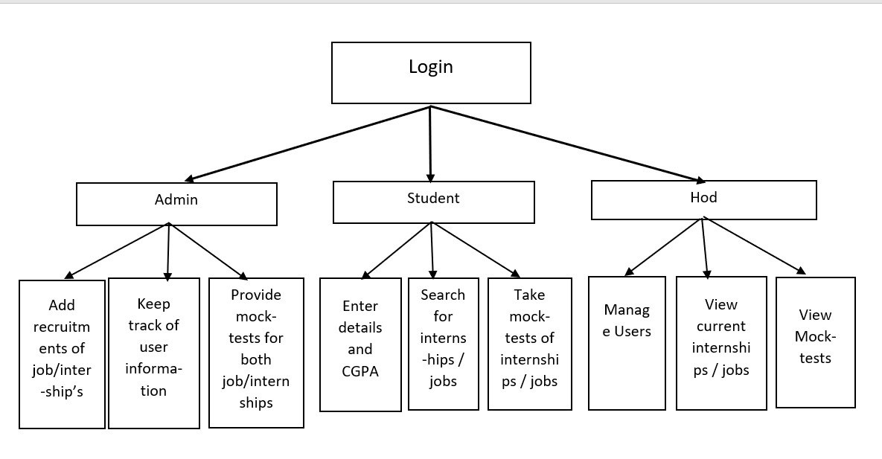

**3.2 Summary of methodology**

**Admin** - The Placement officer is the administrator of the system. Admin plays a very crucial role in the system. Admin can log in through a username and password. He/she can maintain the placement activities via the system. Admin can add Recruitments of internships/Jobs. Admin can create mock-tests for the ongoing internships/jobs based on the previous tests conducted. Admin also keeps track of the user information.

**Student** - Every student is given a default username and password, using this he/she can enter the system. Students can fill the necessary details like name, Email, Phone, Graduation year and CGPA. Student can search for the ongoing job recruitments and apply for those. He/she can also search for the Mock-tests of those internships/jobs within the student module.

**HOD** - Head of the department provides the access to the student as well as the admin by providing role based login system. He can create, update and delete the users of the placement management system. HOD can also keep track of the ongoing internships/jobs as well as the mock-tests of those internships/jobs.

**CHAPTER 4: RESULTS AND DISCUSSION**

**4.1 Summary of results and discussion**

**Login page:**

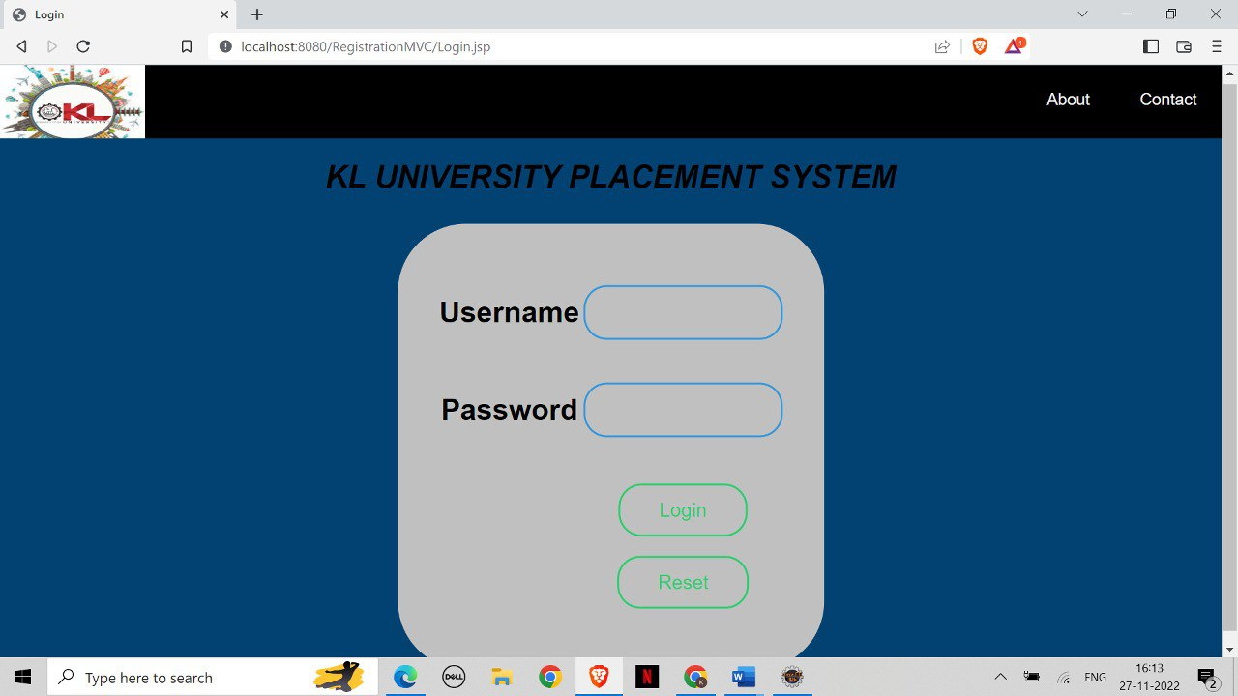

**If given wrong credentials**

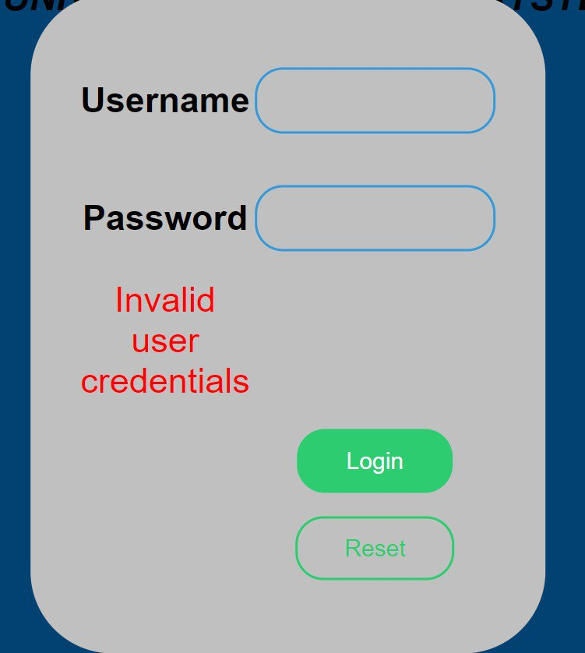

**Admin Module:**

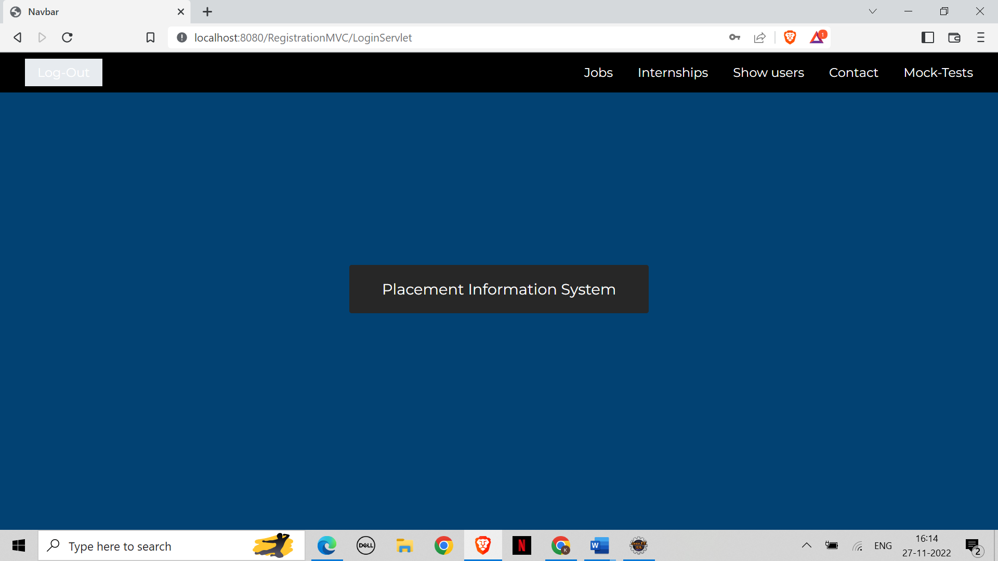

**Jobs**

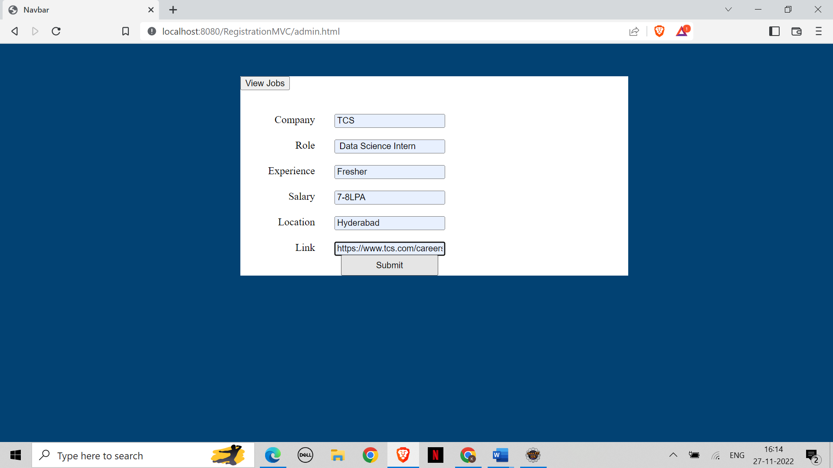

**Internships**

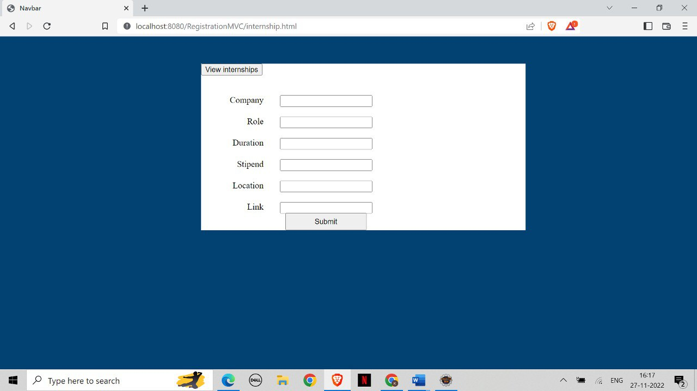

**Show users**

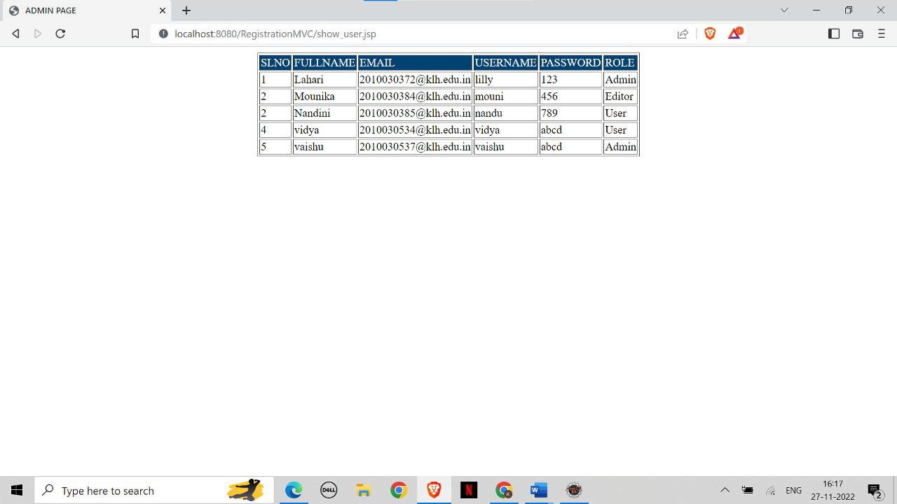

**Contact information**

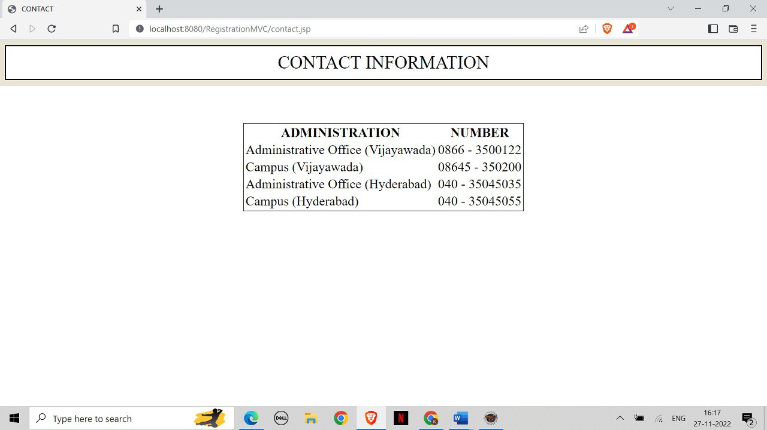

**Mocktests**

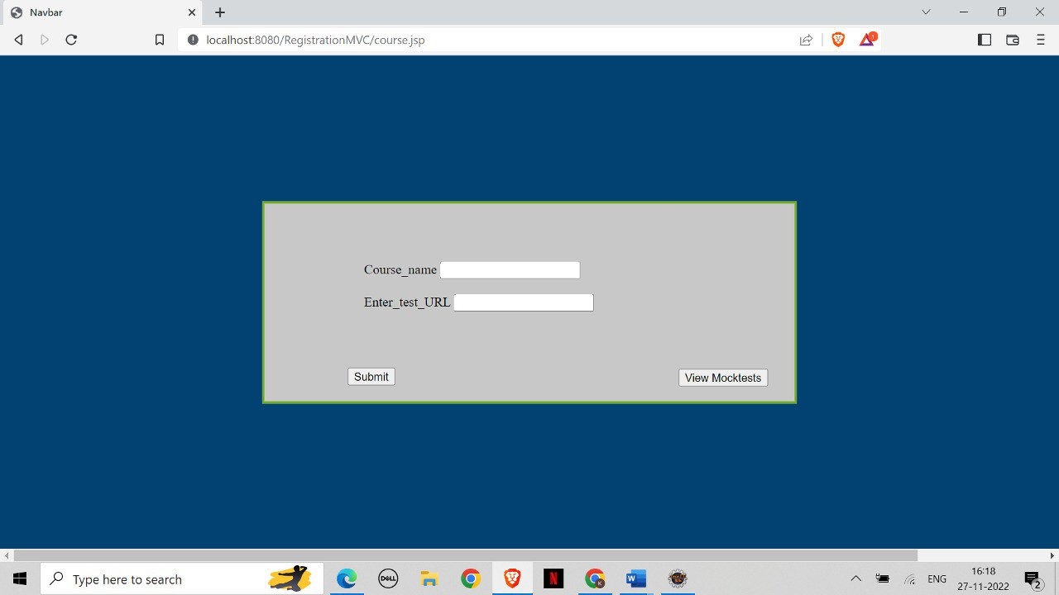

**Student Module:**

**Student details**

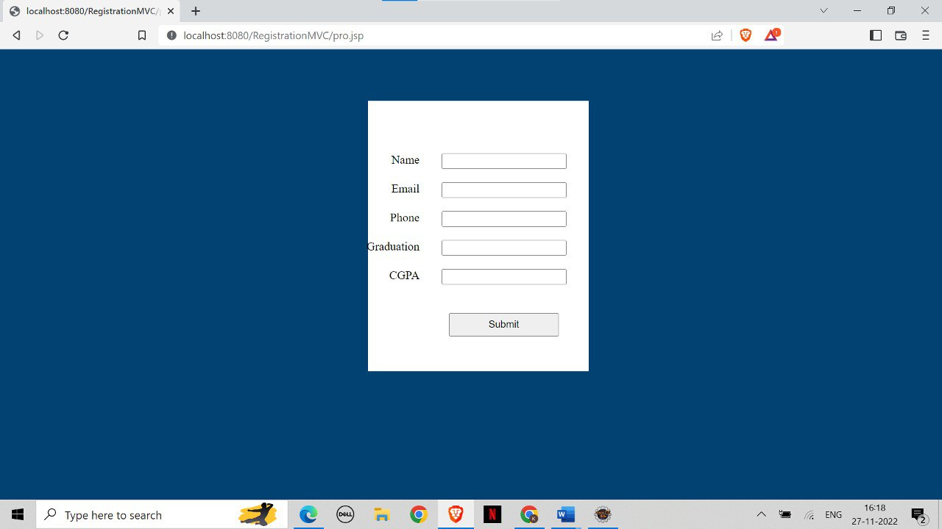

**View jobs**

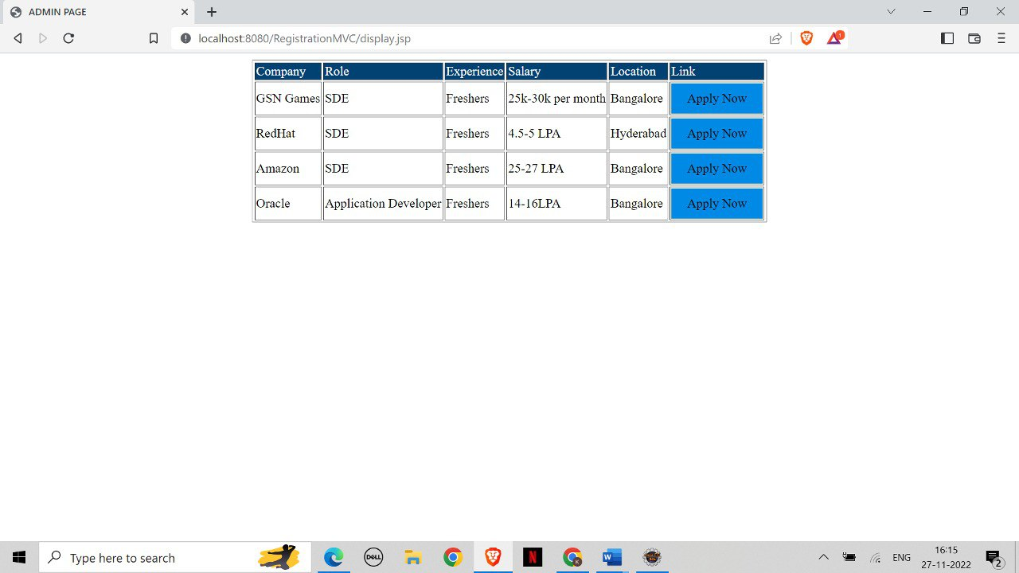

**View internships**

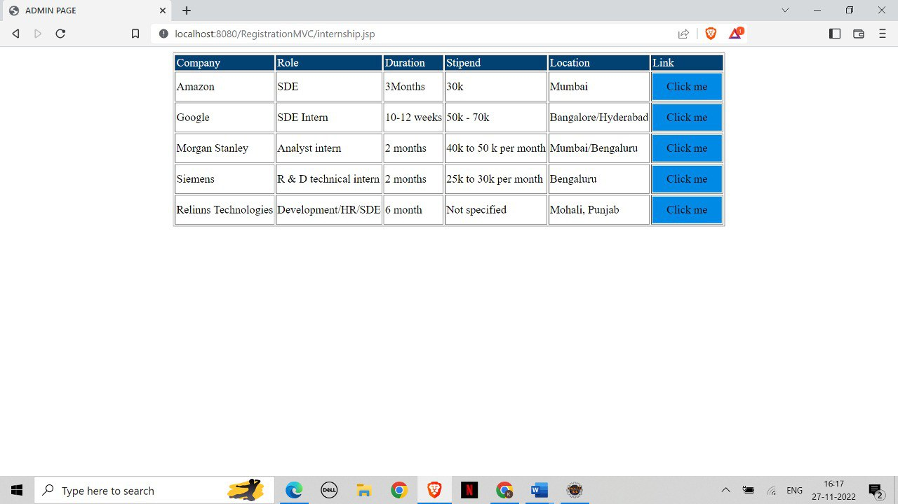

**View mocktests**

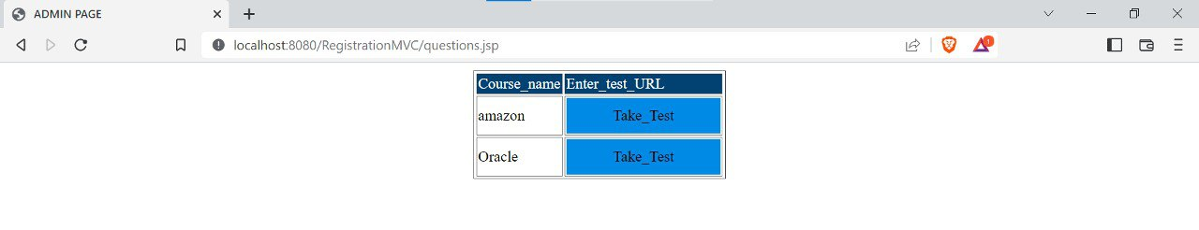

**When clicked on Take_Test**

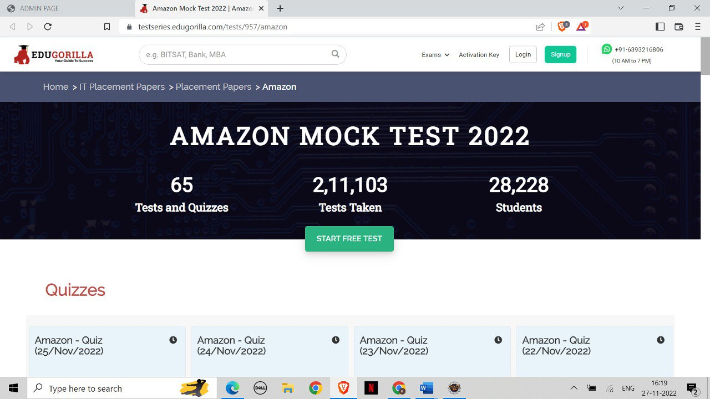

**HOD Module:**

**Manage users**

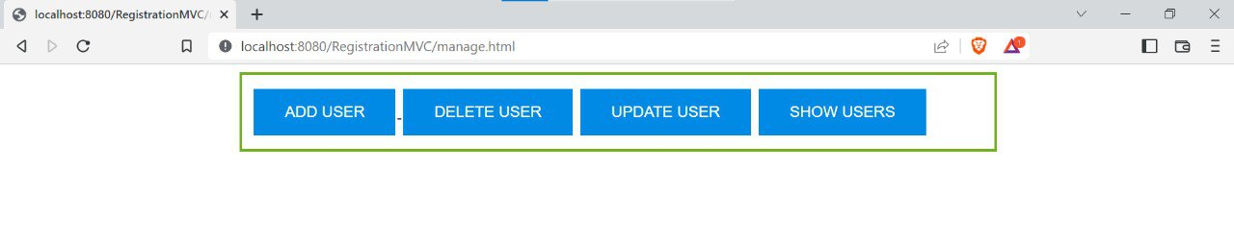**Add user**

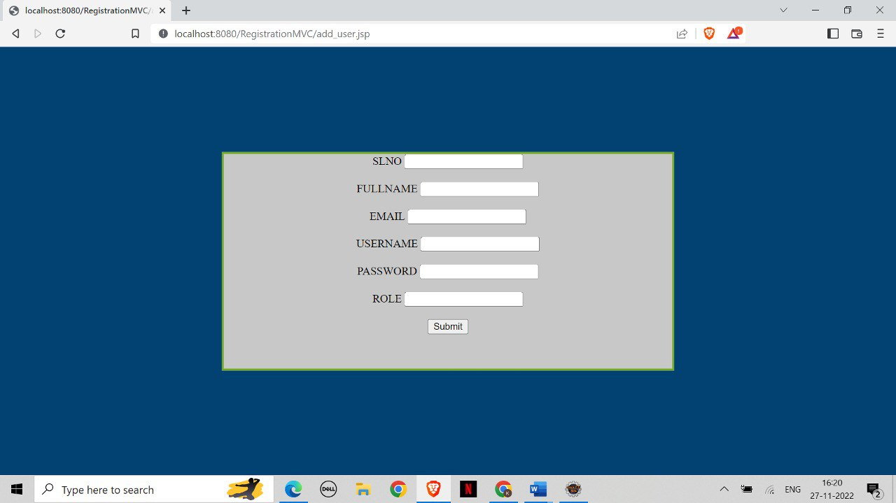

**Show user**

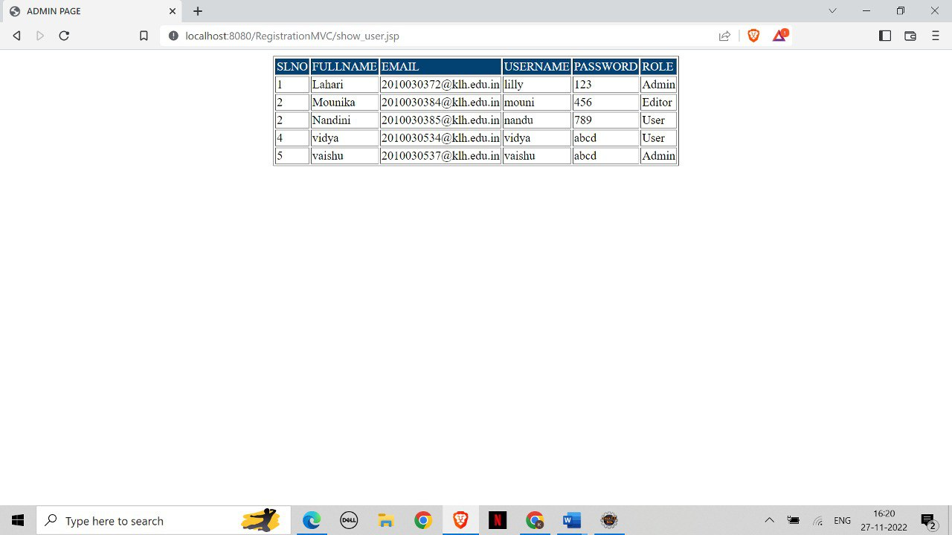

**Database tables:**

**Table for users**

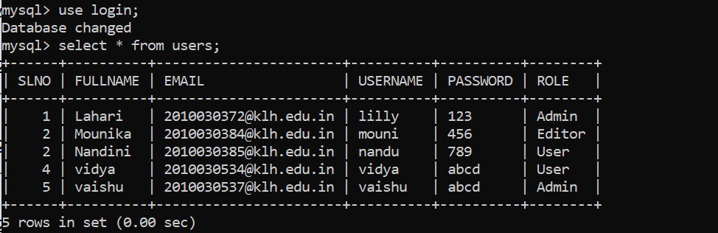

**Student information table**

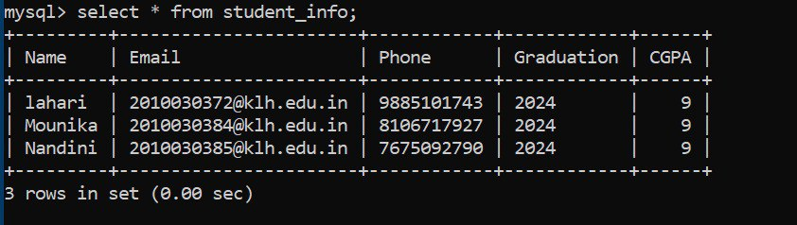

**mock-tests table**

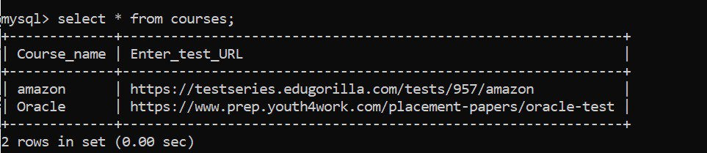

**Jobs table**

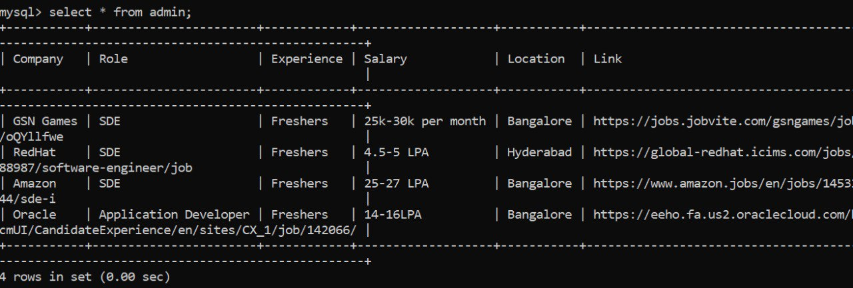

**Internships table**

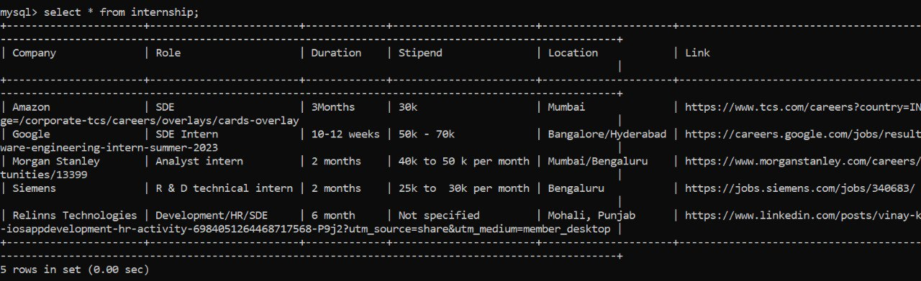

**CHAPTER 5: CONCLUSION**

**5.1 Conclusion**

Maximum work goes manually in the present placement system which makes it take time to avail changes. This includes main problems like searching for the data of students and sorting them along with it. Also, updating student data is a cumbersome job and does not have a method to notify the student in time which makes the management of the placements very difficult.

In the proposed system, all of these problems become automated. The registration of the student for an upcoming placement, the addition of a new user, sharing information of student, the privacy of the student, etc is all met.

**REFERENCES**

1.Almahdi Alshareef, Ahmed Alkilany "Toward a Student Information System for Sebha University, Libya",Fifth international conference on Innovative Computing Technology.

2.Prabhu T Kannan, Srividya K Bansal,"Unimate: A Student Information System",2013 International Conference on Advances in Computing, Communications and Informatics.

3.shiqiu Huang,R zhang,zhengwei Qi: Static program analysis assisted dynamic taint tracking for software vulnerability discovery.

4.S.R. Bharamagoudar, Geeta R.B, S.G.Totad, “Web service api for student information and course management systems”International Journal of Advanced Research in Computer and Communication Engineering.

5.Rajnesh Tripathi, Raghvendra Singh, Jaweria Usmani,”Campus Recruitment and Placement Sys- tem”, International Conference on Recent Innovations in Science and Engineering(Icrise-18), April, 2018.

6.Anjali v, Jeyalakshmi PR, Anbubala R,Sri Mathura devi, Ranjini.V, ”Web Based Placement Management System”, International Journal of Computer Science and Information Technologies(IJCSIT), Vol. 7 (2) , 2016, 760-763.

7.Santhosh Kumar H,” Online Training and Placement Management system” ,International Journal of Engineering Research Technology (IJERT),ICACT -2016 Conference Proceedings.